YTD - SALES

Sales YTD (simple) :=

CALCULATE (

    [Sales Amount],

    DATESYTD ( 'Date'[Date] )

)

Sales YTD :=

IF (

    [ShowValueForDates],

    CALCULATE (

        [Sales Amount],

        DATESYTD ( 'Date'[Date] )

    )

)

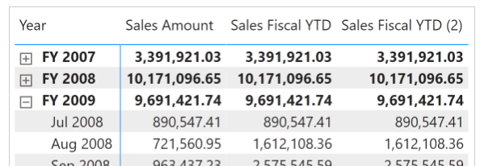

Sales Fiscal YTD :=

IF (

    [ShowValueForDates],

    CALCULATE (

        [Sales Amount],

        DATESYTD ( 'Date'[Date], "6-30" )

    )

)

Sales YTD (2) :=

IF (

    [ShowValueForDates],

    TOTALYTD (

        [Sales Amount],

        'Date'[Date]

    )

)

Sales Fiscal YTD (2) :=

IF (

    [ShowValueForDates],

    TOTALYTD (

        [Sales Amount],

        'Date'[Date],

        "6-30"

    )

)

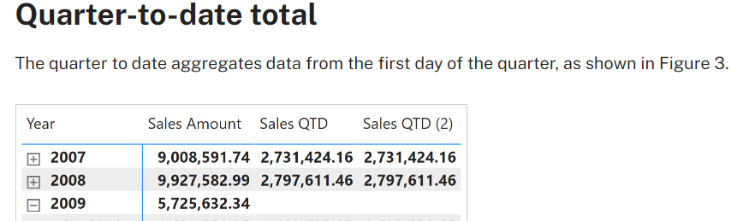

Sales QTD :=

IF (

    [ShowValueForDates],

    CALCULATE (

        [Sales Amount],

        DATESQTD ( 'Date'[Date] )

    )

)

Sales QTD (2) :=

IF (

    [ShowValueForDates],

    TOTALQTD (

        [Sales Amount],

        'Date'[Date]

    )

)

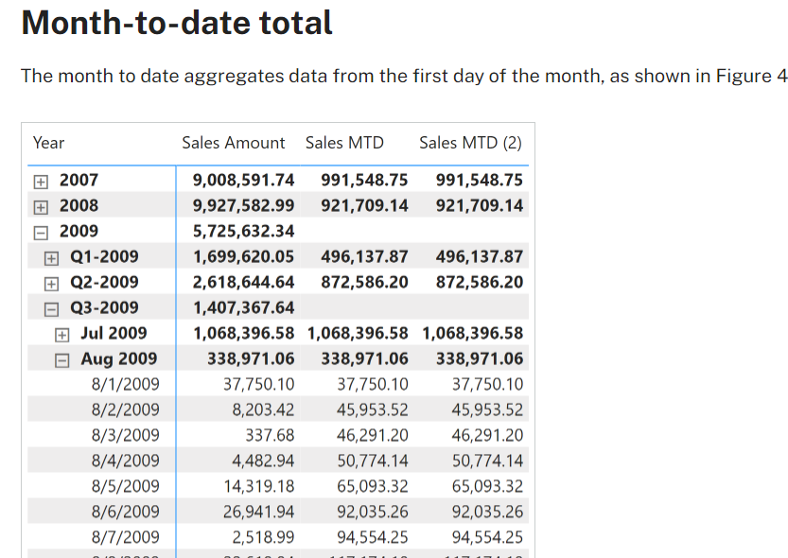

Sales MTD :=

IF (

    [ShowValueForDates],

    CALCULATE (

        [Sales Amount],

        DATESMTD ( 'Date'[Date] )

    )

)

Sales MTD (2) :=

IF (

    [ShowValueForDates],

    TOTALMTD (

        [Sales Amount],

        'Date'[Date]

    )

)

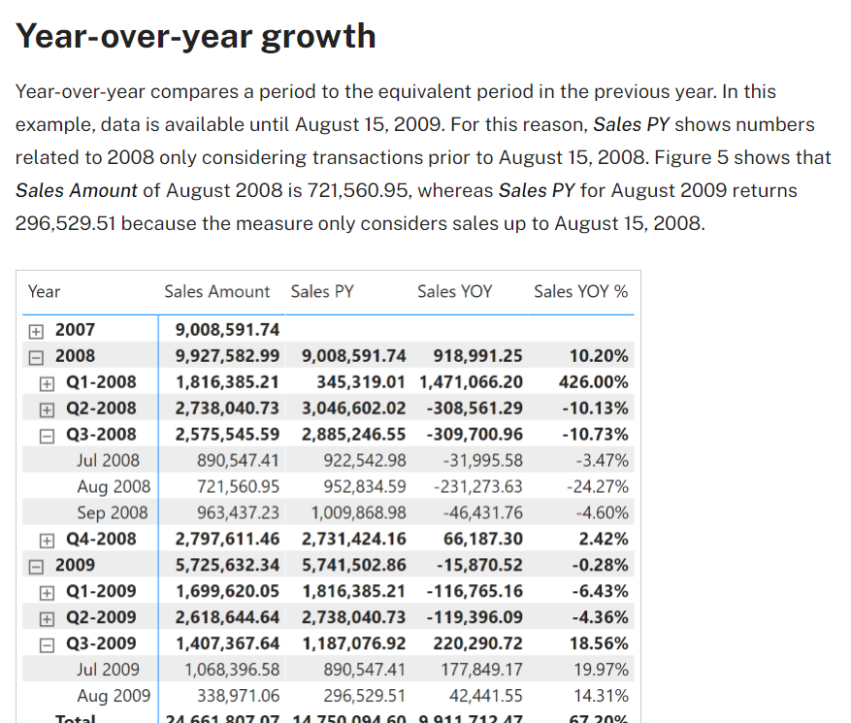

Sales PY :=

IF (

    [ShowValueForDates],

    CALCULATE (

        [Sales Amount],

        CALCULATETABLE (

            DATEADD ( 'Date'[Date], -1, YEAR ),

            'Date'[DateWithSales] = TRUE

        )

    )

)

Sales YOY :=

VAR ValueCurrentPeriod = [Sales Amount]

VAR ValuePreviousPeriod = [Sales PY]

VAR Result =

    IF (

        NOT ISBLANK ( ValueCurrentPeriod ) && NOT ISBLANK ( ValuePreviousPeriod ),

        ValueCurrentPeriod - ValuePreviousPeriod

    )

RETURN

    Result

Sales YOY % :=

DIVIDE (

    [Sales YOY],

    [Sales PY]

)

Sales PY (2) :=

IF (

    [ShowValueForDates],

    CALCULATE (

        [Sales Amount],

        CALCULATETABLE (

            SAMEPERIODLASTYEAR ( 'Date'[Date] ),

            'Date'[DateWithSales] = TRUE

        )

    )

)

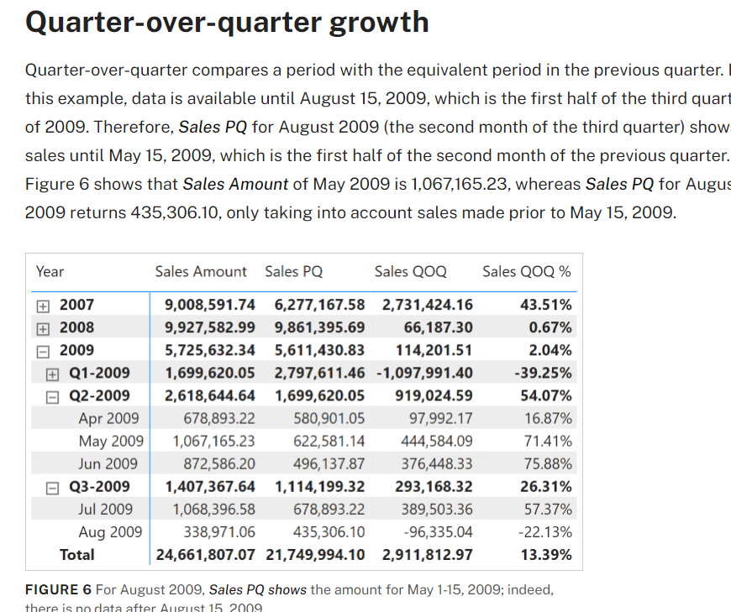

Sales PQ :=

IF (

    [ShowValueForDates],

    CALCULATE (

        [Sales Amount],

        CALCULATETABLE (

            DATEADD ( 'Date'[Date], -1, QUARTER ),

            'Date'[DateWithSales] = TRUE

        )

    )

)

Sales QOQ :=

VAR ValueCurrentPeriod = [Sales Amount]

VAR ValuePreviousPeriod = [Sales PQ]

VAR Result =

    IF (

        NOT ISBLANK ( ValueCurrentPeriod ) && NOT ISBLANK ( ValuePreviousPeriod ),

        ValueCurrentPeriod - ValuePreviousPeriod

    )

RETURN

    Result

Sales QOQ % :=

DIVIDE (

    [Sales QOQ],

    [Sales PQ]

)

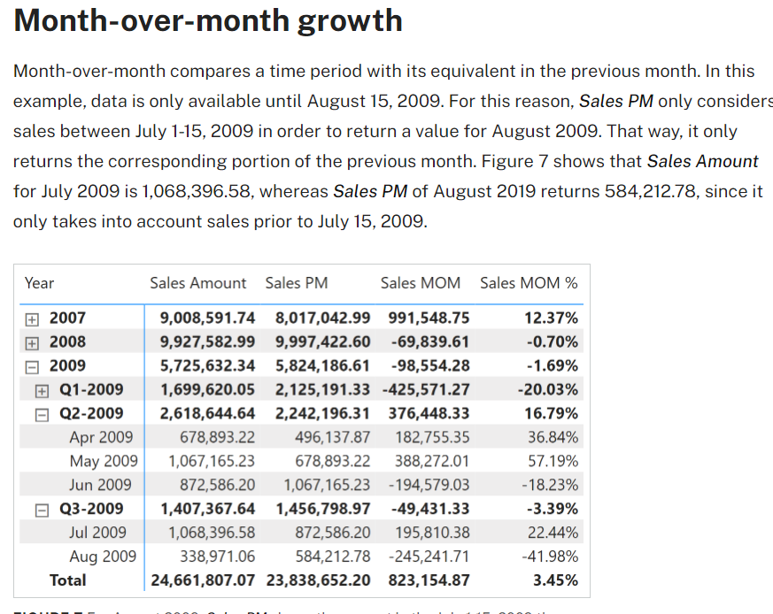

Sales PM :=

IF (

    [ShowValueForDates],

    CALCULATE (

        [Sales Amount],

        CALCULATETABLE (

            DATEADD ( 'Date'[Date], -1, MONTH ),

            'Date'[DateWithSales] = TRUE

        )

    )

)

Sales MOM :=

VAR ValueCurrentPeriod = [Sales Amount]

VAR ValuePreviousPeriod = [Sales PM]

VAR Result =

    IF (

        NOT ISBLANK ( ValueCurrentPeriod )

            && NOT ISBLANK ( ValuePreviousPeriod ),

        ValueCurrentPeriod - ValuePreviousPeriod

    )

RETURN

    Result

Sales MOM % :=

DIVIDE (

    [Sales MOM],

    [Sales PM]

)

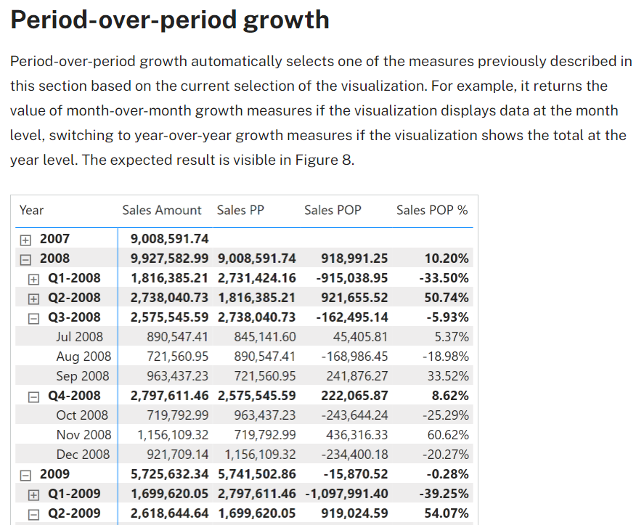

Sales POP % :=

SWITCH (

    TRUE,

    ISINSCOPE ( 'Date'[Year Month] ), [Sales MOM %],

    ISINSCOPE ( 'Date'[Year Quarter] ), [Sales QOQ %],

    ISINSCOPE ( 'Date'[Year] ), [Sales YOY %]

)

Sales POP :=

SWITCH (

    TRUE,

    ISINSCOPE ( 'Date'[Year Month] ), [Sales MOM],

    ISINSCOPE ( 'Date'[Year Quarter] ), [Sales QOQ],

    ISINSCOPE ( 'Date'[Year] ), [Sales YOY]

)

Sales PP :=

SWITCH (

    TRUE,

    ISINSCOPE ( 'Date'[Year Month] ), [Sales PM],

    ISINSCOPE ( 'Date'[Year Quarter] ), [Sales PQ],

    ISINSCOPE ( 'Date'[Year] ), [Sales PY]

)

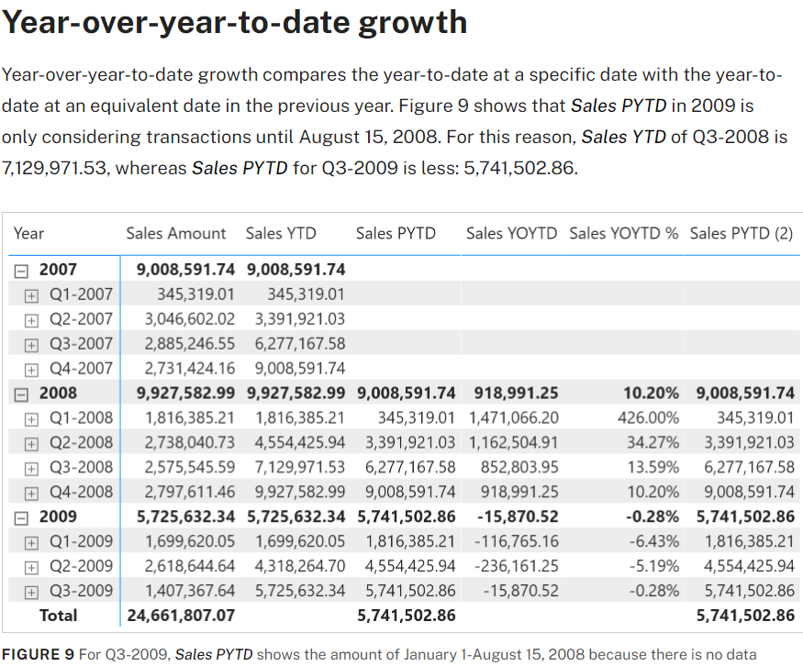

Sales PYTD :=

IF (

    [ShowValueForDates],

    CALCULATE (

        [Sales YTD],

        CALCULATETABLE (

            DATEADD ( 'Date'[Date], -1, YEAR ),

            'Date'[DateWithSales] = TRUE

        )

    )

)

Sales YOYTD :=

VAR ValueCurrentPeriod = [Sales YTD]

VAR ValuePreviousPeriod = [Sales PYTD]

VAR Result =

    IF (

        NOT ISBLANK ( ValueCurrentPeriod )

            && NOT ISBLANK ( ValuePreviousPeriod ),

        ValueCurrentPeriod - ValuePreviousPeriod

    )

RETURN

    Result

Sales YOYTD :=

VAR ValueCurrentPeriod = [Sales YTD]

VAR ValuePreviousPeriod = [Sales PYTD]

VAR Result =

    IF (

        NOT ISBLANK ( ValueCurrentPeriod )

            && NOT ISBLANK ( ValuePreviousPeriod ),

        ValueCurrentPeriod - ValuePreviousPeriod

    )

RETURN

    Result

Sales PYTD (2) :=

IF (

    [ShowValueForDates],

    CALCULATE (

        [Sales YTD],

        CALCULATETABLE (

            SAMEPERIODLASTYEAR ( 'Date'[Date] ),

            'Date'[DateWithSales] = TRUE

        )

    )

)

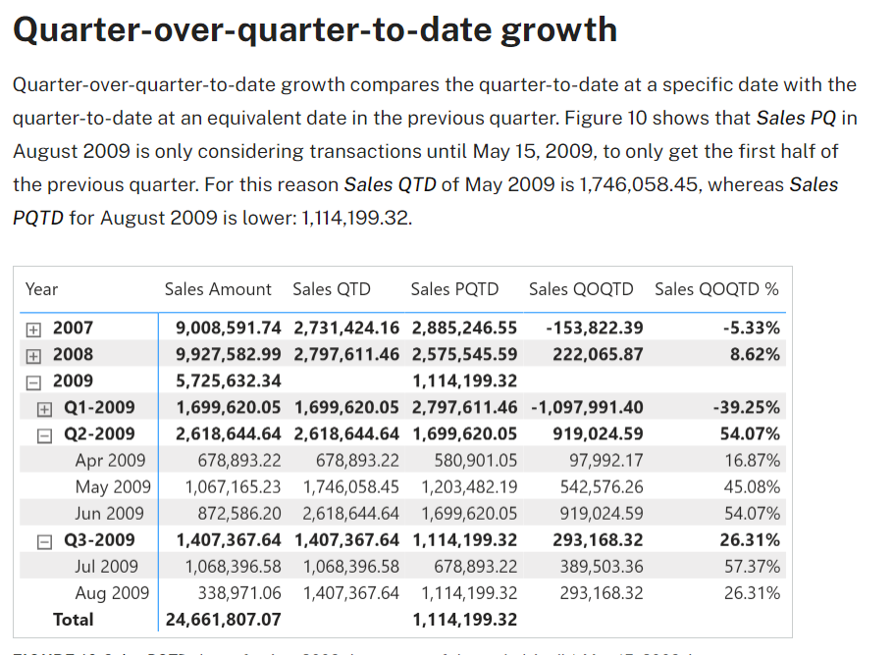

Sales PQTD :=

IF (

    [ShowValueForDates],

    CALCULATE (

        [Sales QTD],

        CALCULATETABLE (

            DATEADD ( 'Date'[Date], -1, QUARTER ),

            'Date'[DateWithSales] = TRUE

        )

    )

)

Sales QOQTD :=

VAR ValueCurrentPeriod = [Sales QTD]

VAR ValuePreviousPeriod = [Sales PQTD]

VAR Result =

    IF (

        NOT ISBLANK ( ValueCurrentPeriod )

            && NOT ISBLANK ( ValuePreviousPeriod ),

        ValueCurrentPeriod - ValuePreviousPeriod

    )

RETURN

    Result

Sales QOQTD % :=

DIVIDE (

    [Sales QOQTD],

    [Sales PQTD]

)

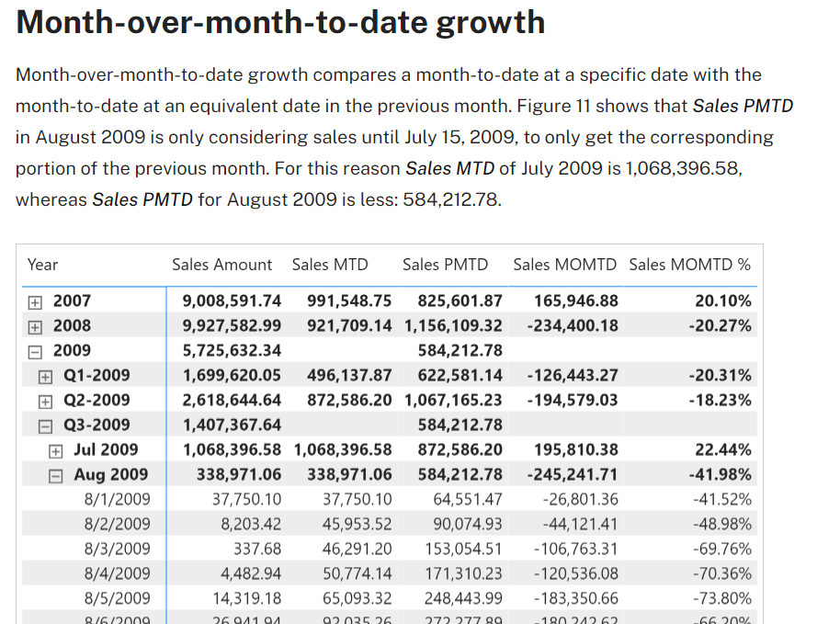

Sales PMTD :=

IF (

    [ShowValueForDates],

    CALCULATE (

        [Sales MTD],

        CALCULATETABLE (

            DATEADD ( 'Date'[Date], -1, MONTH ),

            'Date'[DateWithSales] = TRUE

        )

    )

)

Sales MOMTD :=

VAR ValueCurrentPeriod = [Sales MTD]

VAR ValuePreviousPeriod = [Sales PMTD]

VAR Result =

    IF (

        NOT ISBLANK ( ValueCurrentPeriod )

            && NOT ISBLANK ( ValuePreviousPeriod ),

        ValueCurrentPeriod - ValuePreviousPeriod

    )

RETURN

    Result

Sales MOMTD % :=

DIVIDE (

    [Sales MOMTD],

    [Sales PMTD]

)